**DAILY ONLINE ACTIVITIES SUMMARY**

|  |  |  |  |  |  |  |  |  |
| --- | --- | --- | --- | --- | --- | --- | --- | --- |
| **Date:** | **30 June** | | | | | **Name:** | **Shah Dhruvil Amit** | |
| **Sem & Sec** | **6th Sem ‘B’ Sec** | | | | | **USN:** | **4AL17CS083** | |
| **Online Test Summary** | | | | | | | | |
| **Subject** | | **JAVA Programming** | | | | | | |
| **Max. Marks** | | **--** | | **Score** | | | **Quiz 20/20** | |
| **Certification Course Summary** | | | | | | | | |
| **Course** | **Placement Training** | | | | | | | |
| **Certificate Provider** | | | **Mr. Sharan Pais** | | **Duration** | | | **2 Hours** |
| **Coding Challenges** | | | | | | | | |
| **Problem Statement: 2 programs** | | | | | | | | |
| **Status: Executed** | | | | | | | | |
| **Uploaded the report in GitHub** | | | | | **yes** | | | |
| **If yes Repository name** | | | | | <https://github.com/DhruvilShah99/Daily-Updates> | | | |
| **Uploaded the report in slack** | | | | | **yes** | | | |

**Java programming Session 1:**

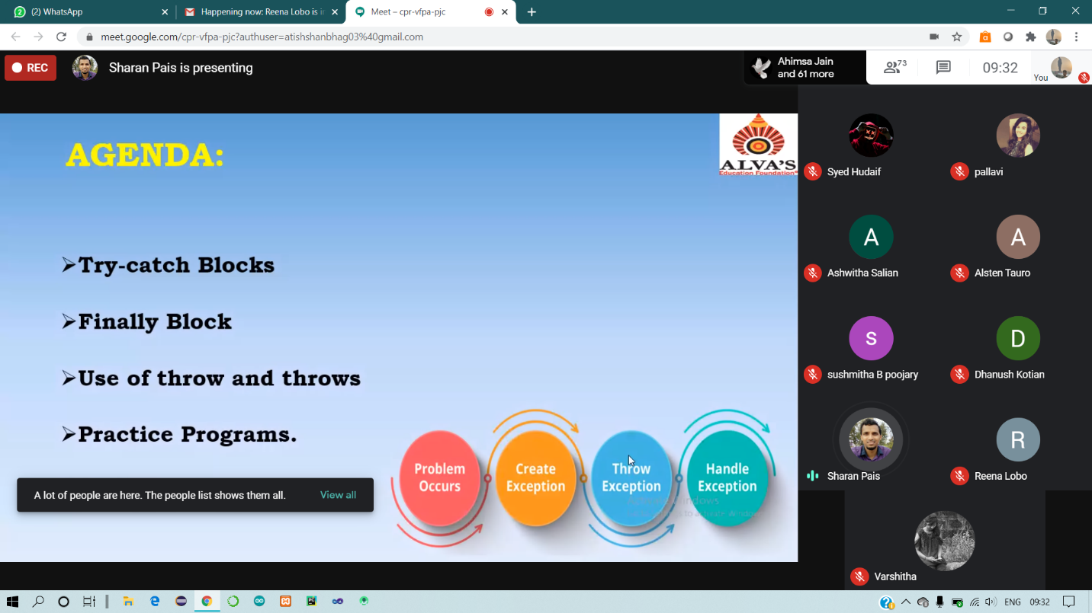

**Coding Challenges Details:**

30 June – Code:

**Program 1 -Rotation**

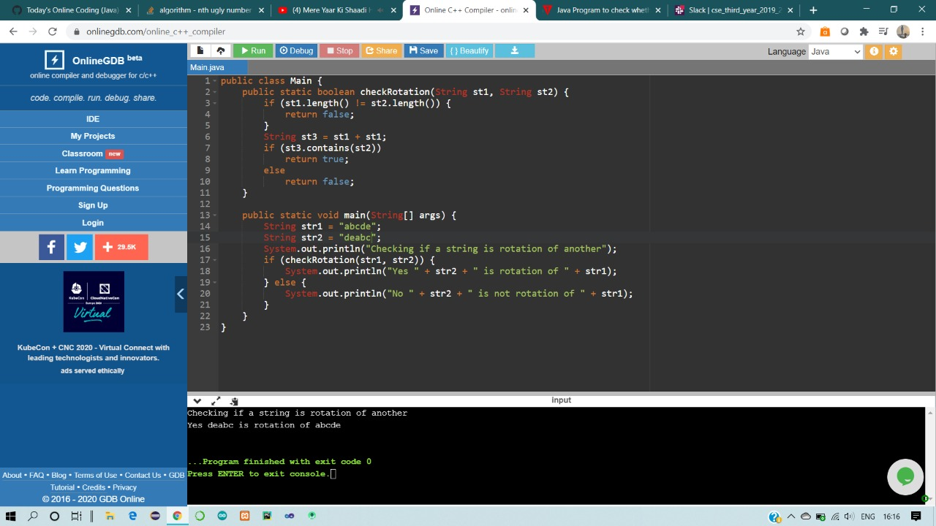

**Program -2 Ugly Number**

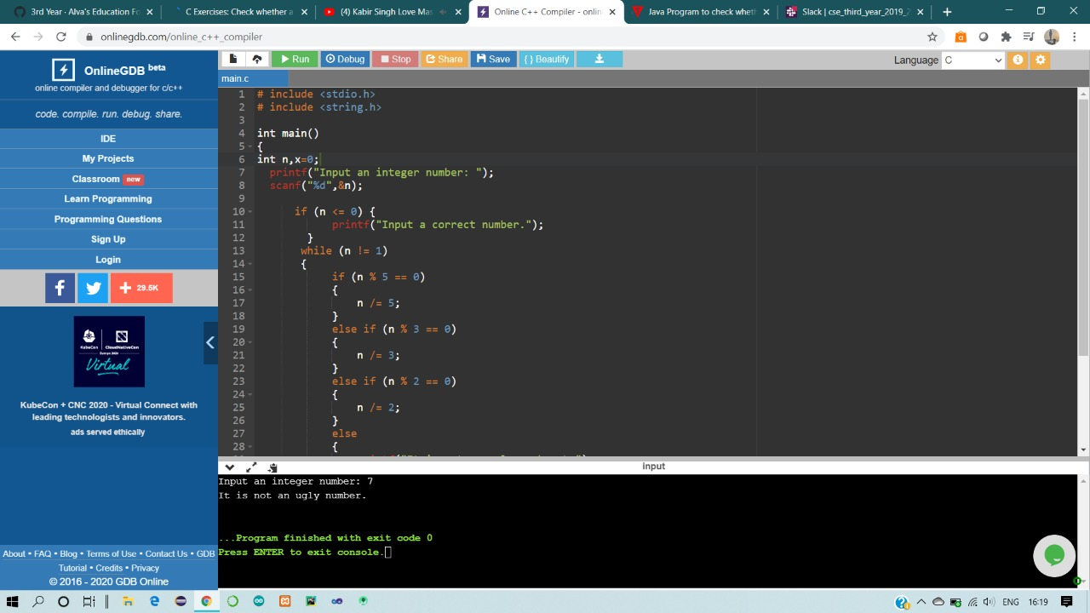

**1-For Report and daily coding challenges** 🡪

<https://github.com/DhruvilShah99/Daily-Updates>